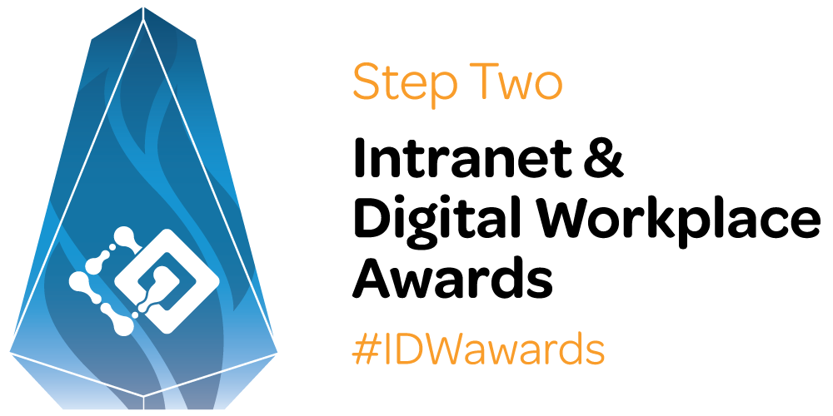

2021
Awards description document

Use this document to describe your entry, and why it’s worthy of an Award
Once you’ve completed this document, use the online form to finish your submission.
Full instructions on how to enter for the Awards can be found online.
The closing date for entries is 26 March 2021 (any time zone).
Contact Steve Bynghall from Step Two if you have any questions or need some advice.

Submission acknowledgements
- Submitting organisations give full permission for Step Two to use the content and screenshots in the Awards report, as well as in other publications and presentations.
- As the results of the awards will be communicated widely, please ensure that no confidential information is included on screenshots.
- When used or published by Step Two all submitted ideas and screenshots will be fully credited to their respective organisation.
- All material and screenshots submitted will only ever be used in positive ways that reflect well on the submitting organisations.

Your submission

Please use this Word form to submit your entry. Simply enter your details under the different headings but please try to avoid duplicating information within the form.
Tip! When judging entries, we are relying on the information you provide in these sections. In general, write more rather than less (although entries should not be of extreme length), and don’t forget to focus on the business benefits provided by your idea. The more evidence, examples, numbers and quotes you can provide, the greater the chance you have of winning a beautiful glass trophy.
You are welcome to embed screenshots in the text to describe what you’ve done, but please note that we will also need them to be recorded at the end of the form, and the images should be uploaded as a Zip file on the online form. (Please also don’t embed any images that you’re not able to also upload.)

Your name
Your email
Organisation name

DESCRIPTION OF ENTRY
Please provide a full description of your project or initiative.

IMPLEMENTATION
Tell us your story. How was your project / initiative implemented?

KEY FEATURES
What are the key features of your initiative or project? Give us the detail we need to be able to get a sense of what you have delivered.

INSIGHTS
How is the solution innovative or unusual? How does it provide new ideas or approaches that other teams can learn from?

IMPACT
How has the solution helped the workforce and measurably benefited the business? Please describe how the initiative has changed how the workforce operates, or how it has delivered business value and benefits.
Note that impact is 50% of the scoring.

EVIDENCE OF IMPACT
Please submit any evidence of impact including specific metrics, feedback and stories. See the entry page for detailed tips on how best to demonstrate impact.
Only use the categories that are relevant for your project, and don’t worry, you don’t need to fill it all in!

Category | Your evidence (only fill in categories where relevant)
Business problems solved
Strategic benefits
Money made or saved
Usability benefits
Time savings
Adoption and usage
Before and after comparison
Quotes from staff or stakeholders
Other evidence of impact

LESSONS LEARNT & ADVICE FOR OTHERS
If you had a chance to do the work again, what you do differently, what suggestions or tips would you give to others considering similar ideas?

SCREENSHOTS & VIDEOS
Important guidelines for screenshots:
- Please provide up to 30 screenshots. Try to get coverage across all aspects of your submission, as more screenshots will help us to better judge your submission.
- If appropriate you may also send a video with your submission.
- Save each screenshot as a separate file.
- Save images in PNG format (not JPEG).
- Put this into a ZIP file to upload into the entry form.
- Please do not add captions or notes to the images, as we require clean images for use in the final report.
- Name each image as follows:
OrgName_Description.png
For example:
AbcCorp_StaffDirectory.png
- Please ensure that any confidential information is removed, blurred or replaced with filler text. For example, this might be personal names and contact details, photographs or sensitive news stories. (The screenshots for submissions may be published publicly.)

Confidentiality | I confirm that no confidential material is included in the screenshots or other material provided.

Screenshot | Filename | Caption (1-3 sentences)
1
2
3
4
5
6
7
8
9
10
12
13
14
15
16
17
18
19
20
21
22
23
24
25
26
27
28
29
30
Video(s)

